User Manual

William Herr

Digital Tournaments

Table of Contents

**Users1**

Problems1

Solutions1

**How to Use the Website2**

**Navigating through the website2**

Home2

Login2

Connections3

Connection Details3

Saved Connections4

New Connection4

Users

DigitalTournament is a website made to connect gamers together. It is a place where people can hangout, play games, watch tournaments, and more. DigitalTournament also host the best online tournaments in esports. Tournaments include many games like Dota 2, Counter-Strike, Fortnite, League of Legends, StarCraft II, and more. Que up with your friends to win the tournament or attend the tournament to connect with other people while spectating the games. Make new friends by playing games with people you never met before. Sign up for available spots at the connection section.

Problems

Many times, when watching esport tournaments online, people are watching it by themself. Some people may want to play games with friends, but some may not have anyone to play with.

Solution

That is where Digital Tournaments come in. Digital Tournaments allow a platform where gamers can have a place to hangout or create new friends. They can meet and watch tournaments or play games together.

How to Use the Website

First, download the esport.zip folder and extract it. Open the unzipped folder into your IDE and write into the terminal nodemon app.js. The website will be live and hosted on your local host. Type in http://127.0.0.1:3000/ to go to the website.

Navigating through the Website

In the navigation bare there is home, connection, about, contact, sign up, and login page. When logged in, you will see the saved connections and new connections page.

**Home**

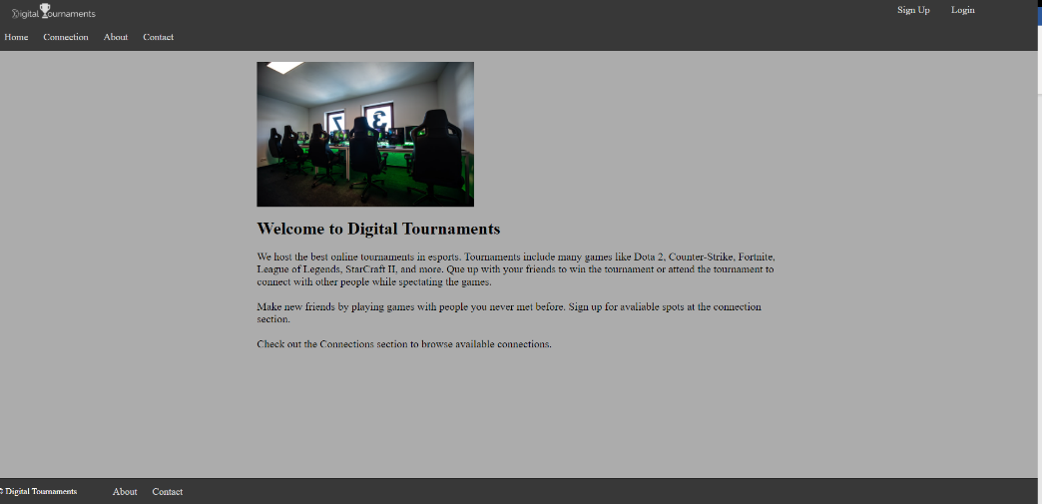

**Login-** There are 2 users saved into the data based. Login in by using one of the users.

User 1: William Herr

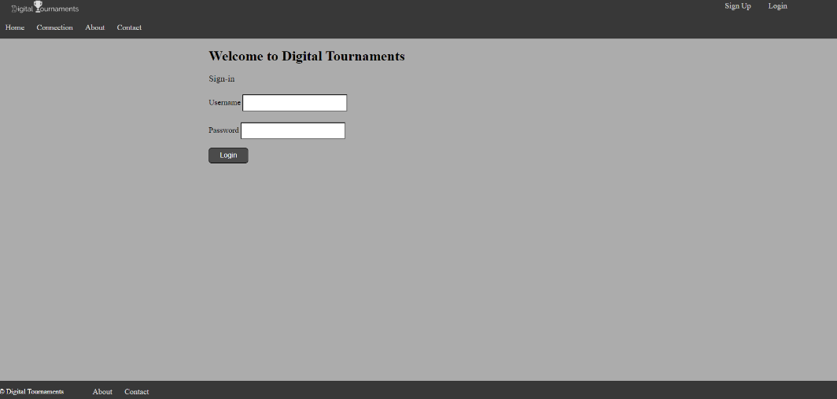Username: [email@email.com](mailto:email@email.com)

Password: 1234

User 2: Yasmine Yang

Username: [yang@email.com](mailto:yang@email.com)

Password: 1111

**Connection-** Shows all connections that have been created. Click any connections to go to the connection details page.

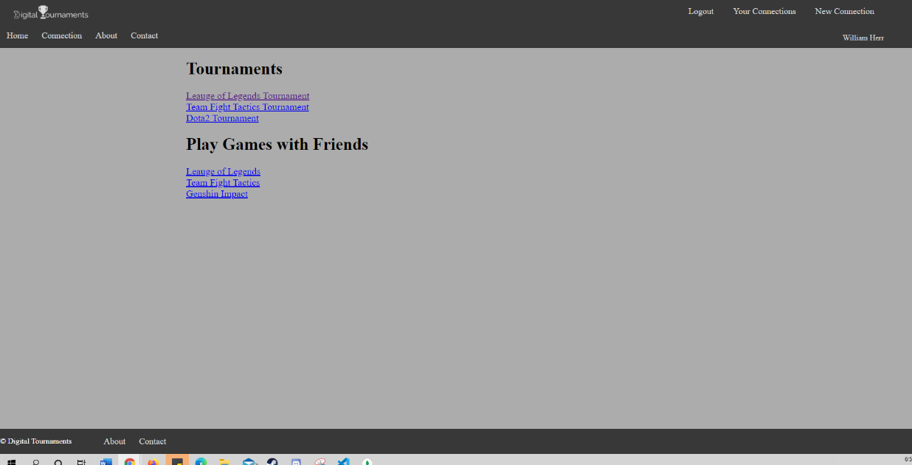

**Connection Details-** Shows the individual connections. Click Yes or Maybe to save the connection. No will delete the connection on your saved connection if you have already saved it.

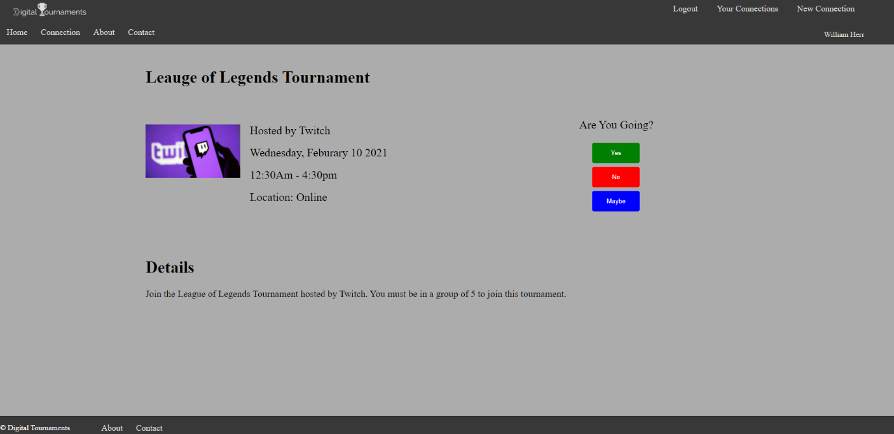

**Saved Connections**- This page shows all of the connections that the users are going to. Click delete to delete any of the connections and click update to edit any connections. The update button will take you to the connection detail page.

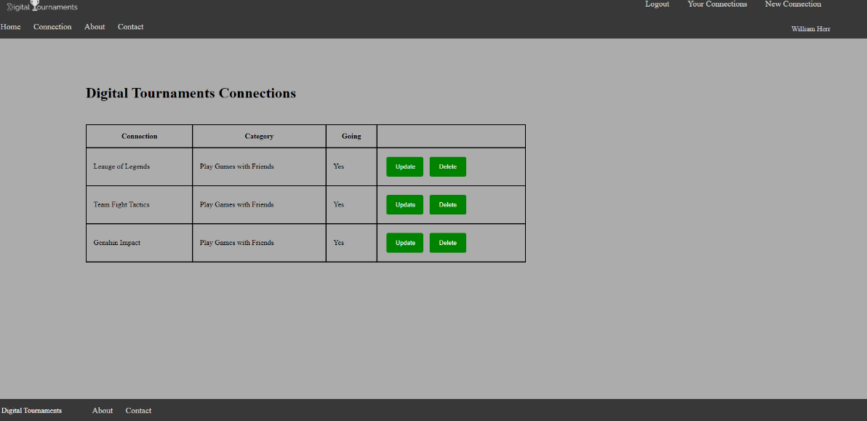

**New connections-** This page allow users to create a new collection. To create a new collection, type in the connection name, topic, details, location, time, and date. When you are done with the connection information, click submit. The new connections will be created.

